**SMALS Multirun SOP**

**Single or Multirun?**

* Use the Single run SOP and program Harvest for clean samples that are not changing over time (or if you don’t care about the changes). Inverse Laplace transforms are easiest here, too.
* Conditions to use this Multirun SOP and associated Multirun Excel-VBA program to gather sequential runs with no filtering by ALV:
  + Dusty samples! It really is better to clean them, but sometimes the best option is to measure multiple runs and exclude bad ones using the Multirun program.
  + A sample that is changing. In this case, the Multirun program just gathers the result in a convenient way.
  + Even for a single run, you have access to the floating baseline cumulants and multiexponential facilities.

**Instrument on**

* Flip the switch at the back right (viewed from behind) corner of the Wyatt DAWN EOS.
* Flip on switches 1 to 8 on the A-Neutronics power distribution box
* Sign on to computer as SMALS (or .\SMALS if necessary) with PW mult!angle8

**Initial screen**

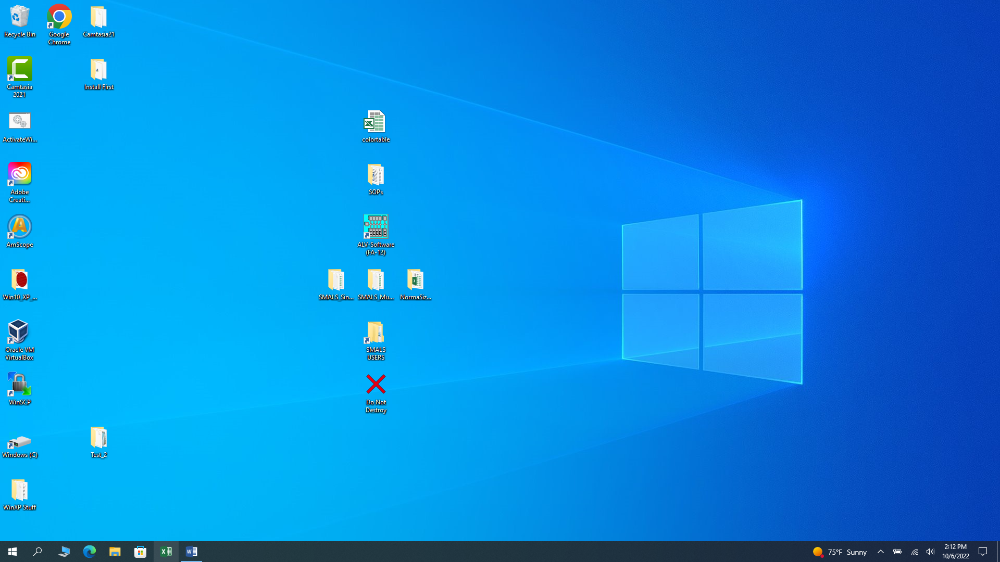

**Make a copy** of SMALS_Multi_Bundle & rename it in your own directory under SMALS­_Users. The bundle directory contains the latest versions of our software. You will rename it and store data here.

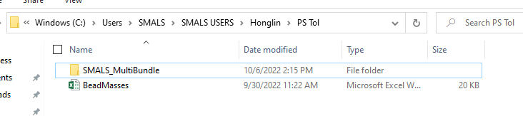

**↓rename**

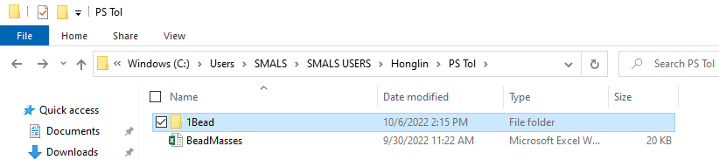

**Optional: Copy address as text (for later use; maybe store it in Notepad)**

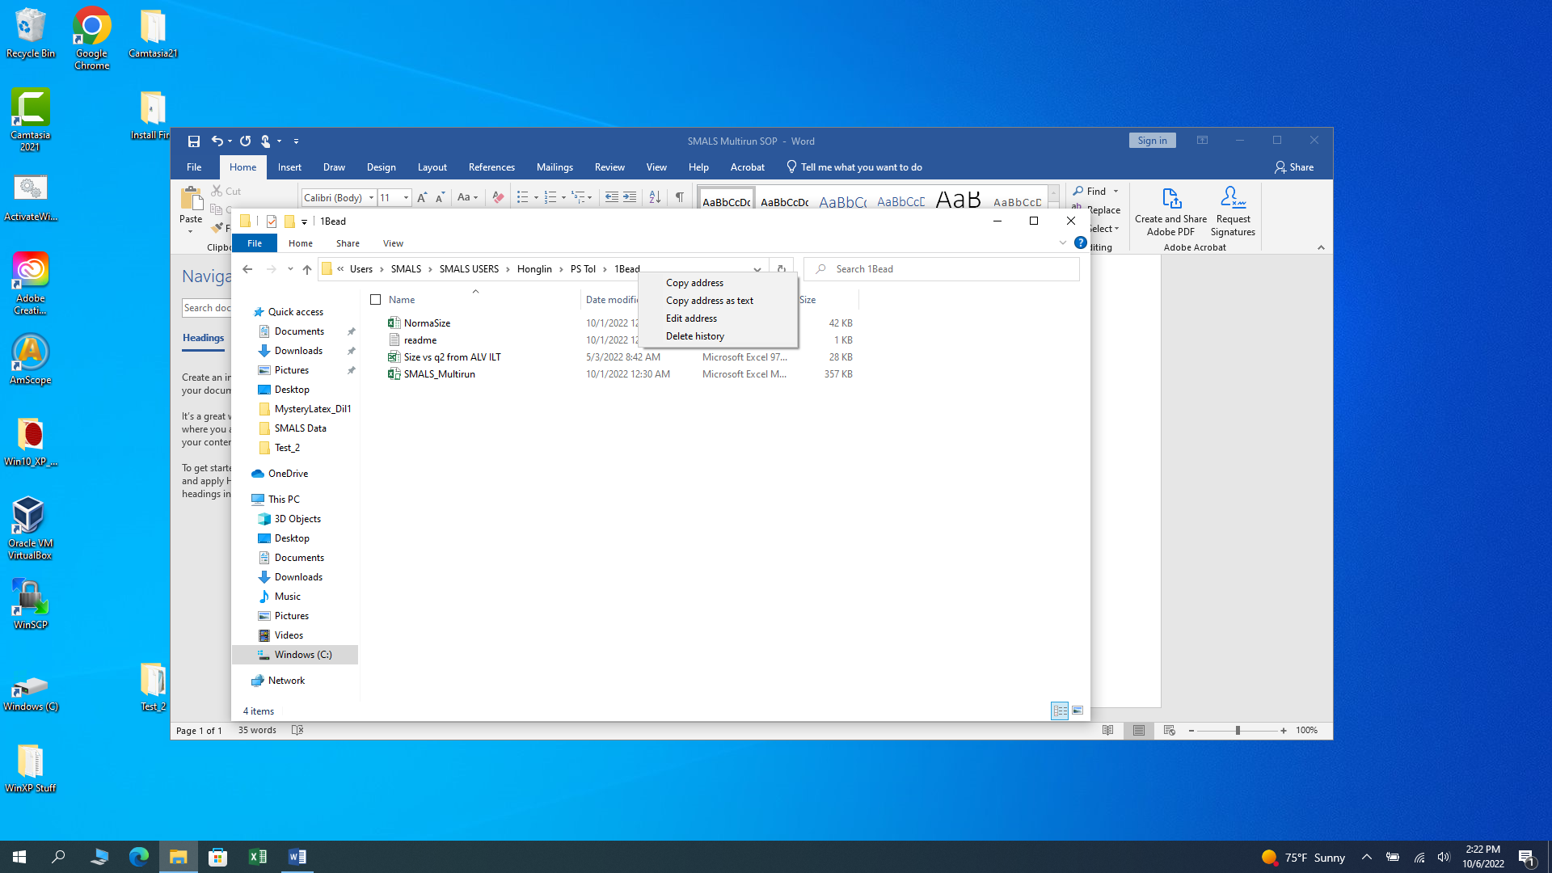

**Launch ALV software** (icon should be in the middle of a mostly empty screen)

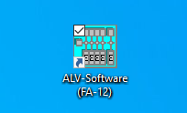

**Choose AutoSave:**

File>>Set>>AutoSave >> Check “Use AutoSave for automatically saving data files”

After AutoSave is chosen (and only after that) you can navigate to your directory, which should be something like: C:\Users\SMALS\SMALS USERS\Honglin\PS Tol\1Bead

Type a convenient name (not many details here; use the readme file in your directory instead for those).

Click OK

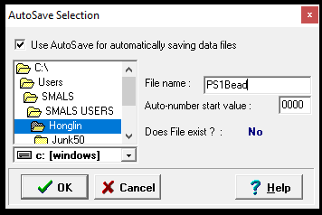

**Set File Options.** On the ALV software, click File >> Options

If all detectors on your instrument are quiet (no correlated afterpulsing) then you might skip just the first few channels, not 15 as shown here (to get around a problem with one of our eight detectors). These parameters affect how the ALV cumulant operation will work. You can use the SMALS_Multirun cumulants instead later on.

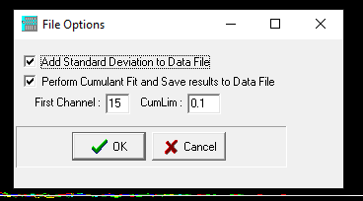

**Display 4 graph panels**

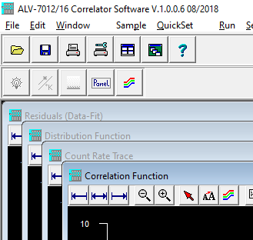

**Remove black cap**

**Insert sample**

Hold one hand between your eyes and the Wyatt’s cell holder to protect you from a brief possible laser flash during insertion.

With your other hand, insert scintillation vial with beamstop (optional) facing forward.

Rotate slightly to fight scratches (an expert will show you how).

Check that Wyatt EOS forward beam monitor reads nearly zero (gently push blue buttons on Wyatt until you see F .001 or some other small number).

Elevating the sample slightly (1 mm) is suggested to reduce vibrations.

(*There is an option that shuts down the laser whenever the black cap is removed, but this is excessive, unless your laser safety officer says otherwise. Simply remove the jumper pin at the back left of the instrument with its top removed. This jumper pin has a label (flag) on it. Then plug the wired jumper leading away from a magnet on top of the cell holder into that slot. This is the preferred method of operation, as lasers usually require warm-up after a shut-down).

**Replace black cap** (theoretically, this reduces room light; in practice, it seems not to matter)

**Press run button** (or function button F2 if using a valid keyboard, not the Lenovo’s)

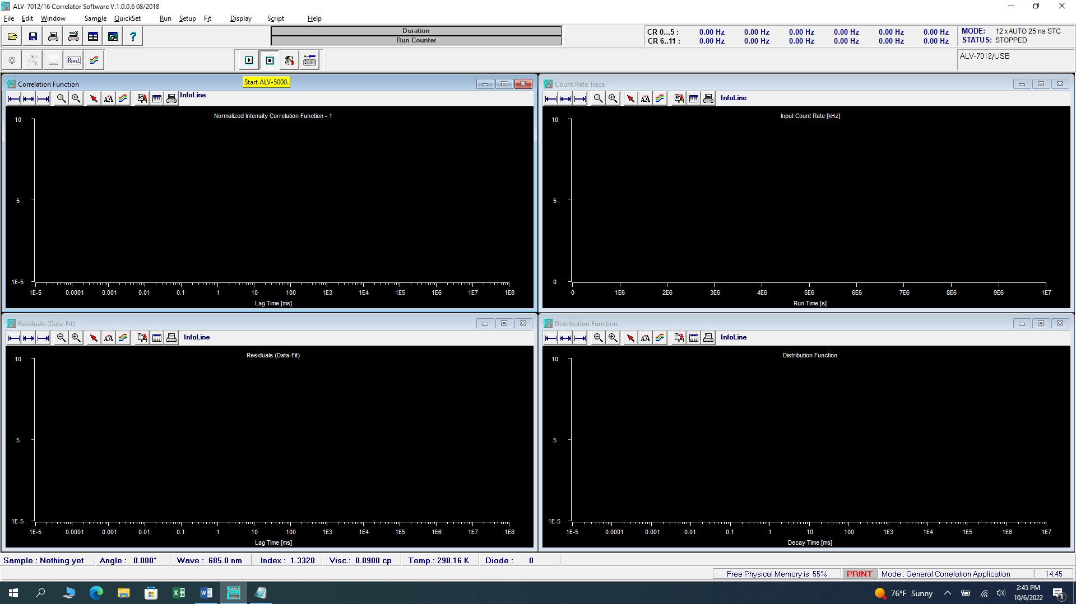

The system will generate one short run.

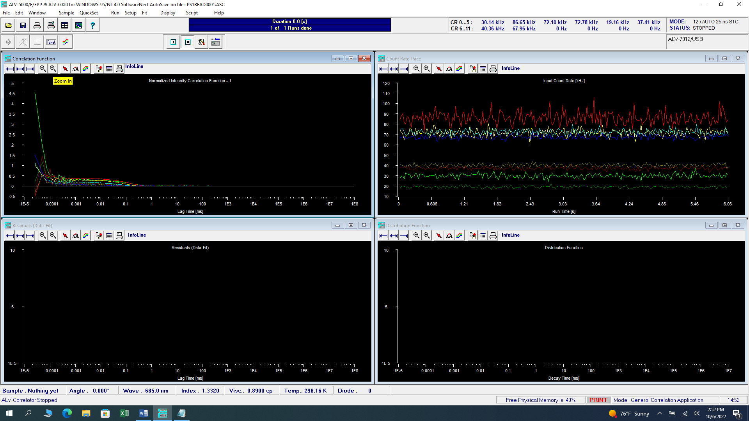

↓↓ Click Magnify to ignore the noise at low lag times (correlated afterpulsing)

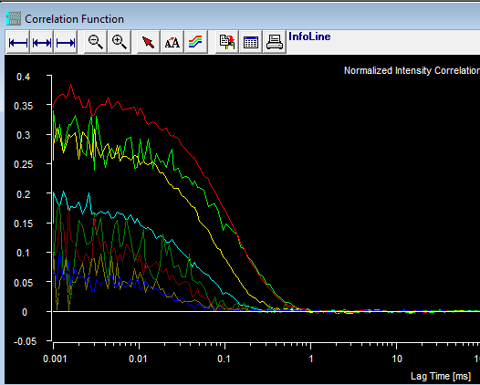

**Set up multiple runs**

* Click setup >> ALV-Correlator setup >> Duration & Runs tab >> Set Single/Multiple Run Details
* Choose Individual Runs, no Correlation Fct. Averaging
* Choose Create additional list file
* Choose No Filter applied (should not matter in this mode)
* Ignore Attenuator Mode Selection
* Choose your times based on how long you think the sample remains clean (if you are doing this to remove dust effects) or your “slice time” in a kinetic run (in which case you can also select the time to wait after runs).

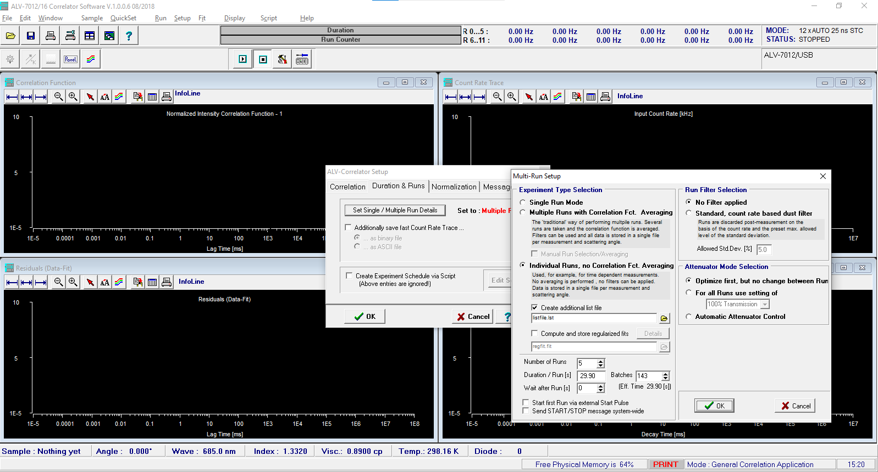

* Click OK twice.

Click Run button (or F2 if keyboard allows)

Observe that the files are being saved properly by navigating to your specified directory. (Use the directory address you saved for convenience, or just mouse-and-click ‘til you get there).

Hint: It is tedious to navigate in the ALV software, so don’t be surprised if you goofed earlier and your data are sent somewhere else. It is usually possible to find them in a nearby directory. Just copy & paste them where you originally intended them to go.

**Inspect your directory**

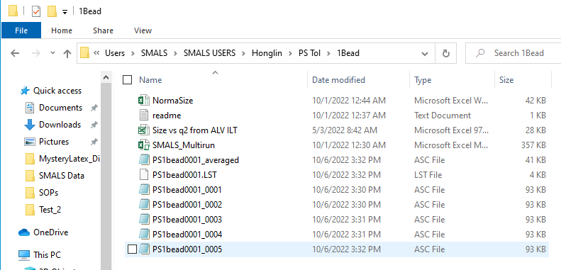

**Analyze Data**

* Edit your readme file to store any observations. Super important!
  + Lab notebook page & number of sample
  + Observations about the run
  + Filter type & size you used to clarify sample, if any
  + Concentration, whatever else you want.
* Locate the file SMALS_Multirun_Blank.xlsm in your directory. Rename it to SMALS_Multirun.xlsm. The program will crash if this name is not used. It’s a data security procedure to keep you from accidentally overwriting data.
* Refer to our YouTube video for how to select and analyze data.

[MultiRun analysis of DLS data: mining good results from a really awful sample. - YouTube](https://www.youtube.com/watch?v=BDgrFGFUml0)

* Rename your completed file, e.g., SMALS­_Multirun_Done (this helps to prevent data-loaded files from being used in the next set of experiments; it is best to start with a clean sheet, although you might want a clean one with all your parameters, such as temperature and viscosity).